**Course Name: Machine Learning**

**Section : A [Spring21-22]**

**Project Proposal**

**Group Member Information**

**NAME : Fahim Abu Talha ID: 18-38125-2**

**NAME: Asif, Abu Junaed Mohd ID: 19-40464-1**

**NAME : Rahman, Mahjabin ID: 19-40336-1**

**NAME: Ovizit Das Joy ID: 18-37945-2**

**Submitted By: Fahim, Abu Talha, ID : 18-38125-2**

**Title: CNN architecture to classify the MNIST handwritten dataset**

**using Machine Learning.**

**Abstract**: MNIST contains a huge number of handwritten text data sets, which are frequently used for CNN deep model training, testing, and validation. In this tutorial, we created an efficient model with several relu and pooling layers. On the MNIST data set, which of the following is rated with 98.45% accuracy? This model is also tested on a similar type of random picture data set, which provides excellent accuracy results.

**Introduction**: Recognizing handwritten numbers is critical, and it can be used in a variety of ways in online handwriting recognition. There are numerous challenges to face when attempting to solve this problem. Handwritten digits contain a wide range of strokes, widths, thicknesses, orientations, and margin lengths, making identification more difficult. The goal was to use CNN to recognize a handwritten digit with a similar pattern and develop a model that could categorize a digit based on its pattern. A Convolutional Neural Network (CNN) is a form of artificial neural network that is used to analyse visual data in deep learning. The greatest performance on the handwritten digit recognition challenge from random photos and the MNIST dataset was demonstrated in this paper using an unique CNN model. The images are of handwritten numeral digits retrieved from a source. Modifying the model architecture was attempted to increase the accuracy to over 98 percent. To determine actual accuracy, it is also tested with various optimizers (Adam, SGD, RSMProp)to identify the actual accuracy.

# Result:

Test accuracy using Adam is 99.08%.

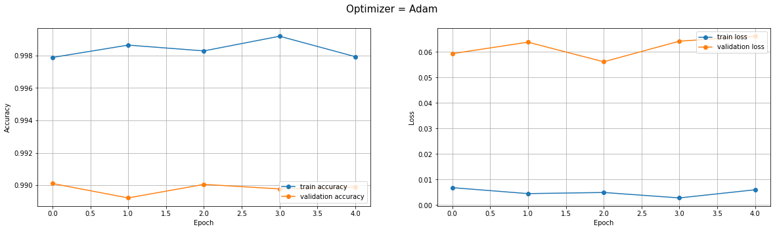

Test accuracy using SGD is 99.35 %.

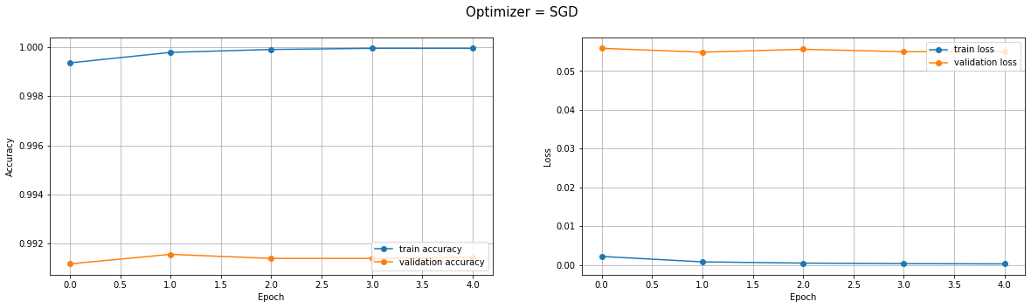

Test accuracy using RMSprop is 99.36 %.

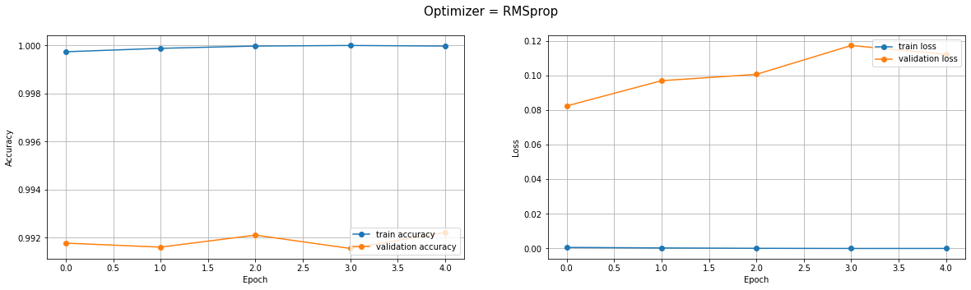

**Discussions**: RMSprop optimizer is preferred because to its accuracy, according to the report's findings. This optimizer has a 0.79 percent loss ratio. It has pseudo-curvature information and is a fairly robust optimizer. It is well-suited to stochastic objectives, making it suitable for micro batch learning. It is more convergent than momentum.